- Which two clauses of the SELECT STATEMENT FACILITATES ROW FILTERING and COLUMN filtering.
- SELECT , FROM
- ORDER BY , WHERE
- SELECT, WHERE
- WHERE, FROM

- Which of the following where clause contains an error:
SELECT * FROM EMPLOYEES
  - WHERE HIRE_DATE IN(‘02/JUN/17’, ‘02/JUN/07’);
  - WHERE SALARY IN(1000,2000,7000);
  - WHERE JOB = (SALESMAN,MANAGER);
  - WHERE COMMISSION IS NULL;

- Choose the WHERE clause that extracts the Department_name values containing the character literal ‘er‘ from DEPARTMENT table.
SELECT * FROM DEPARTMENT
  - WHERE DEPT_NAME IN (‘%er%’);
  - WHERE DEPT_NAME LIKE (‘%er%’);
  - WHERE DEPT_NAME BETWEEN ‘%e’ AND ‘%r%’;
  - WHERE DEPT_NAME CONTAINS ‘e%r’

- Which of the following two conditions are equivalent to each other?
SELECT * FROM EMPLOYEES
  - WHERE SALARY < 5000 AND SALARY >2000
  - WHERE SALARY IN (2000,3000,4000,5000)
  - WHERE SALARY BETWEEN 2000 AND 5000
  - WHERE SALARY >=2000 AND <=5000

- WHICH statements reports on UNIQUE JOB values from the EMPLOYEES table. (Choose all that applies)
- SELECT JOB FROM EMPLOYEES
- SELECT UNIQUE(JOB) FROM EMPLOYEES
- SELECT DISTINCT(JOB) FROM EMPLOYEES
- SELECT JOB FROM EMPLOYEES ORDER BY JOB
- After describing the EMPLOYEES table with SALARY column having data type NUMBER(8,2). Which SALARY values are permitted in this column?
- 11224456
- 112244.56
- 11224.456
- 112244

- Which statements regarding single-row functions are true? (choose all that may apply)
- They may not have any parameter
- They mandatorily have atleast one parameter
- They execute once for each record processed
- They return more than one result.

- Which of the following are single-row character case conversion functions
- LOWER
- SMALLER
- BIGGER
- INITCAPITAL
- INITCASE

- What value is returned after executing the following statement
SELECT SUBSTR(‘How_long_is_a_piece_of_string’,5,4) FROM DUAL;
- _long
- long
- piece
- ERROR

- What value is returned after executing the following statement
SELECT INSTR(‘How_long_is_a_piece_of_string’,’_’) FROM DUAL;
- 4
- 5
- 4,9,12,14,20,23
- None of the above

- What value is returned after executing the following statement
SELECT ADD_MONTHS(SYSDATE,-1) FROM DUAL;
  - 07/FEB/18
  - 07/JAN/18
  - 07/MAR/18
  - None of the above.

- What value is returned after executing the following statement
SELECT TO_CHAR(SYSDATE,’DD-MONTH-YYYY’) FROM DUAL;
  - 07-FEBUARY-2018
  - SEVEN-FEBURARY-2018
  - WED-FEBURARY-2018
  - None of the above

CONSIDER THE COMPANY database;
EMPLOYEE
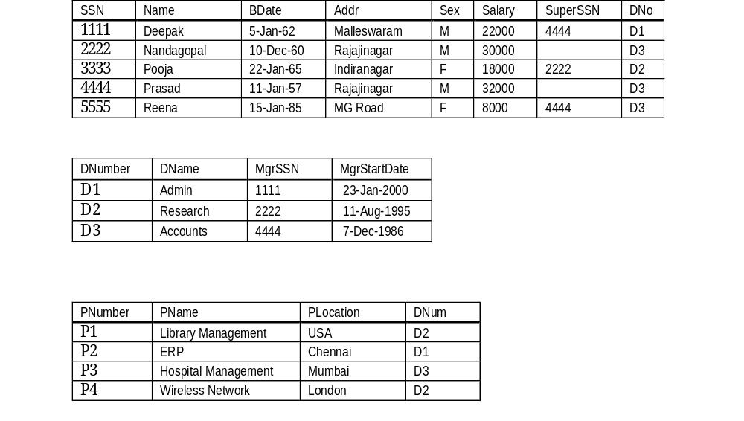

DEPARTMENT

PROJECT

- RETRIEVE ALL EMPLOYEES IN DEPARTMENT 5 WHOSE SALARY IS BETWEEN $30,000 AND $40,000.
- RETRIEVE THE SOCIAL SECURITY NUMBERS OF ALL EMPLOYEES WHO WORK ON PROJECT NUMBER 10,OR 20, OR 30.
- RETRIEVE THE NAMES OF ALL EMPLOYEES WHO DO NOT HAVE SUPERVISORS.
- FIND THE SUM OF THE SALARIES OF ALL EMPLOYEES, THE MAXIMUM SALARY, THE MINIMUM SALARY, AND THE AVERAGE SALARY.
- COUNT THE NUMBER OF DISTINCT SALARY VALUES IN THE DATABASE.
- FOR EACH DEPARTMENT, RETRIEVE THE DEPARTMENT NUMBER, THE NUMBER OF EMPLOYEES IN THE DEPARTMENT, AND THEIR AVERAGE SALARY.
- FOR EACH PROJECT, RETRIEVE THE PROJECT NUMBER, THE PROJECT NAME, AND THE NUMBER OF EMPLOYEES WHO WORK ON THAT PROJECT.
- FOR EACH PROJECT ON WHICH MORE THAN TWO EMPLOYEES WORK, RETRIEVE THE PROJECT NUMBER, THE PROJECT NAME, AND THE NUMBER OF EMPLOYEES WHO WORK ON THE PROJECT.

